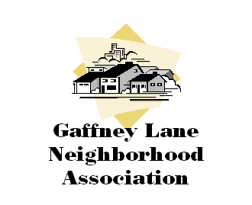

**Minutes of the General Meeting**

**Month DD, 20YY**

1. Call to Order – Chair, Amy Willhite – 7:06 p.m.
2. **In Attendance**:

* Amy Willhite - chair
* Angela Wright -Secretary/Treasurer
* Joan Schultze
* Tony Konkol - OC City Manager
* Sharon Mora
* Pamalyn Richardson
* Jack & Becky Wright
* Ed Turpin
* Jerry Crawley
* Michelle Don – Citizens Bank
* Jon McGrew – Hennebery Eddy
* Camilla Cok – Hennebery Eddy
* Brian Rooney - Battalion Fire Chief
* Shane Thomas CCFD
* Clay Buford CCFD
* David Elle CCFD
* John Wood CCFD
* John Fetzer OCPD
* Cynthia Gates OCPD
* Mike & Joy Albin
* Cherie Ludwig
* Don Brandon
* Elizabeth Summer
* Rachel Smith

1. **Old Business** - Minutes of the Meeting held on XXXXX, 20XX were approved unanimously.
2. **New Business**

* **Officer Liaison’s Name, Topic.** Discussion. Consensus or vote
* **Guest Speaker, Topic.** Discussion. Consensus or vote
* **Guest Speaker, Topic**. Discussion. Consensus or vote
* **Topic**. Discussion. Consensus or vote

**Meeting adjourned at 9:14 pm**